St James’ Yeovil
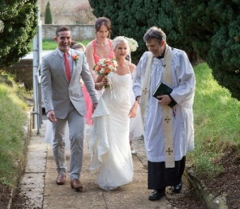
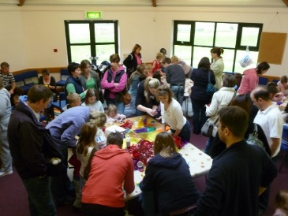
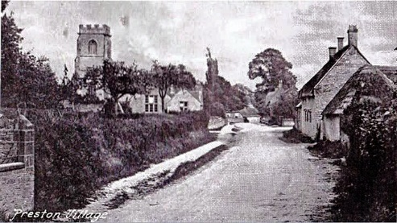
1420-2020
Celebrating 600 years
at the heart of the community
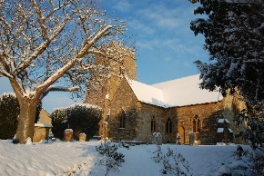

A year of events, exhibitions, food, food for thought, celebrations and much more, to mark our 600th year as a place of worship and prayer, and a hub of community life.
Please Come and Join Us!
Winter/Spring Season
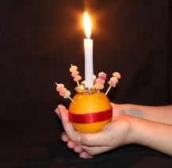
Sunday Feb 2nd: 4.30pm Candlemas Christingle Service – including renewal of Baptism promises, followed by tea and cake.
Saturday 8th Feb: New2You sale 10-2 in church and room with snack lunches available.
Friday 14th Feb: 6.30pm Renewal of Marriage vows service for Valentines Day, with nibbles and bubbly in the church room after.
Wednesday 26th Feb: Ash Wednesday- 7.30pm Communion service to mark the start of Lent.
Lent Talks – Tuesday 7.30pm from 3rd March
- Has Science Disproved Christianity?
- Is the Bible Reliable?
- Aren’t All Religions the Same?
- How Can A Good God Allow So Much Suffering?
- Does Religion Do More Harm Than Good?
Saturday 21st March: Spring fair 10-2, a wide range of stalls, competitions, and items for sale, refreshments and lunch also available.
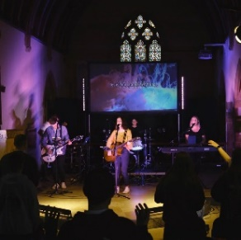
Sunday 22nd March: 10.30am Special service for all ages to celebrate Mothering Sunday.
Sunday 26th April 7:00pm Movement Youth Worship Night, joint event with youth groups across the town.
Easter Week 5-12th April
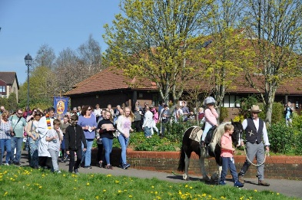
Sunday 5th April: Palm Sunday Procession, starts 10.30am at Abbey Community Centre, following the donkey (or the nearest we can find!) down to St James’.
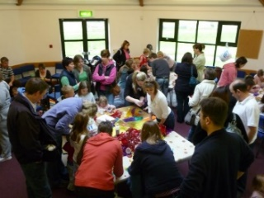
Friday 10th April Good Friday Family Fun 2-4pm, crafts, games, Easter themed activities, egg decorating, Easter Egg hunt, bell tower tours, drop in any time through the afternoon, £2 per family.

Sunday 12th April 10.30am Easter Sunday Celebration
Summer Season
Saturday 16th May: Rogation Walks. Following the ancient tradition of ‘beating the bounds’ – walking the parish boundary – there will be organised walks of varying distances, with afternoon tea in the Church room.
Thursday 21st May: Ascension Day. 7.30pm service leading into 10 Days of prayer, church open 24 hours a day for prayer, meditation and reflection, and to pray for requests left by visitors.
July 2020 – Festival Month
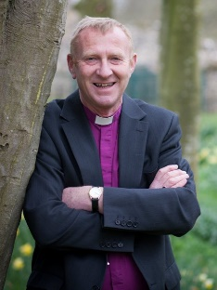
Sunday 5th July 10.30am United Celebration in St. James’ with our sister church St. Peter’s Westfield, with special guest Rt. Rev Peter Hancock, Bishop of Bath and Wells.
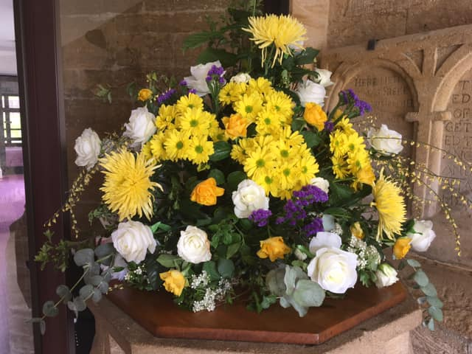
Saturday 18th – Sunday 19th July: Flower Festival in Church 10am – 4pm both days, refreshments in Church Room. Spectacular displays in a beautiful setting.

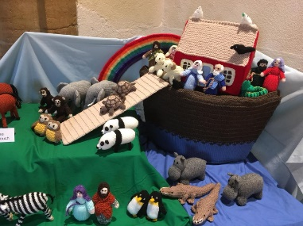
Wednesday 22nd-Saturday 25th July: Knitted Bible Stories Exhibition in Church, Local History Exhibition in Church Room, with refreshments during the day.
Sunday 26th July: St James’ Day. 10.30am service of celebration, followed by a picnic in the church grounds.
Details of autumn events available later this year, including…..St Francis’ Day Pet Blessing…..Star Quilters Exhibition…..Model Railway Exhibition…..Sponsored Cycle around local churches….Harvest Festival…Wave of Light Vigil…Special Halloween and All Saints events
Plus all our regular weekly groups…. And the church open Mon-Fri 10am – 4pm for visitors.
For more details go to http://www.stjamesyeovil.org.uk/
or ring 01935 414097

